Title

Sarah J. Hart, Asha Paudel, Josh Carrell, Maxwell Cook

Sept 20, 2023

# Abstract

# Highlights

# Introduction

1. Climate change, species distribution, and adaptive management
2. Integration of species distribution models and remote sensing
   * Species distribution models (SDMs) have been widely used to identify suitable habitats (REF) and predict species range shifts (REF) and inform management practices (REF).
   * Most of the published SDMs use species occurrence data from herbaria, species atlases, field surveys, expert range maps, and citizen science, but lack (He et al., 2015), however most of these datasets lack information on species absence.
   * More recently data from remote sensing have been used to produce SDMs (Bradley and Mustard, 2006). Remotely sensed maps of species precence and absence offer several advantages, relative to traditional species occurrence data, Notably, species distribution maps produced by remote sensing methods exhibit less spatial bias and provided information on species absences (He et al., 2015).
   * Remotely sensed spatially continuous data products can allow for more robust assessments of future range shifts by incorporating locations of known populations and information on dispersal distances.
3. Why aspen
   * widely distributed
   * biodiversity & other ecosystem services
4. Study objectives
   * Specifically our objectives are to: (1) better understand the relationships between aspen presence and climate, topographic, and edaphic factors and (2) map the area suitable for aspen under current climate conditions, and (3) project areas where aspen may expand, contract, or remain stable.
   * Differences from previous research

# Materials and Methods

## Study area

The study area consists of the Southern Rocky Mountains Ecoregion (SRME), an area of approximately 145,700 km2 that extends from southern Wyoming to northern New Mexico (Fig. 1. The SRME consists of rugged, topography with elevation ranging from 1450 m to above 4400 m, seven mountain ranges that largely trend north-south, and four Intermontane basins (Drummond, 2012). The climate of the SRME is characterized by a continental climate, with hot summers (mean July maximum temperature of 24.5°C) and cool winters (mean January minimum temperatures of -12.3°C), and moderate precipitation (mean annual precipitation of 625 mm), most of which falls as snow (Lukas et al., 2014; Rodman et al., 2021). At local scales, the climate is driven by elevation gradients, the prevailing westerly winds, and the north-south orientation of the mountains. Temperatures are warmer at lowerr elevations, while more precipitation falls at higher elevations, particularly on the windward side of the Rockies (Lukas et al., 2014). Summer precipitation patterns exhibit a distinct latitudinal gradient, where more southern locations often receive more precipitation due to the North American Monsoon system (Lukas et al., 2014).

Ecosystems of the SRME correspond with topoclimatic patterns; low elevation valleys and intermountain basins are dominated by grasslands and shrublands, forest occupy intermediate elevations, while grasses, sedges, cushion plants, forbs, mosses, and lichens dominate cold, alpine elevations (Comer, 2001). Within the ca. 55% of the SRME that is forested (Drummond, 2012), topoclimatic variation drives tree species composition. Lower montane forests (< 2,300 m) are generally composed of ponderosa pine (*Pinus ponderosae*) woodlands, piñon (*Pinus edulis*) and juniper (*Juniperus* spp.) woodlands, and gambel oak (*Quercus gambelii*) shrublands. Forests of the upper montane zone (ca. 2,300 - 2,800 m) are dominated by ponderosa pine-Douglas fir mixed conifer systems, quaking aspen, and lodgepole pine (*Pinus contorta*). Forests of the subalpine zone (ca. 2,800 m - 3,200 m) are dominated by Engelmann spruce, subalpine fir, and to a lesser limber pine (*Pinus flexilis)* and Rocky Mountain bristlecone pine (*P. aristata*). Forests dynamics across the SRME are strongly shaped by climate-sensitive disturbances, notably wildfires, outbreaks of native bark beetles, and windstorms [Peet (1981); Baker and Veblen (1990); Veblen et al. (1994); Veblen et al. (2000); Chapman et al. (2012); Hart et al. (2014)).

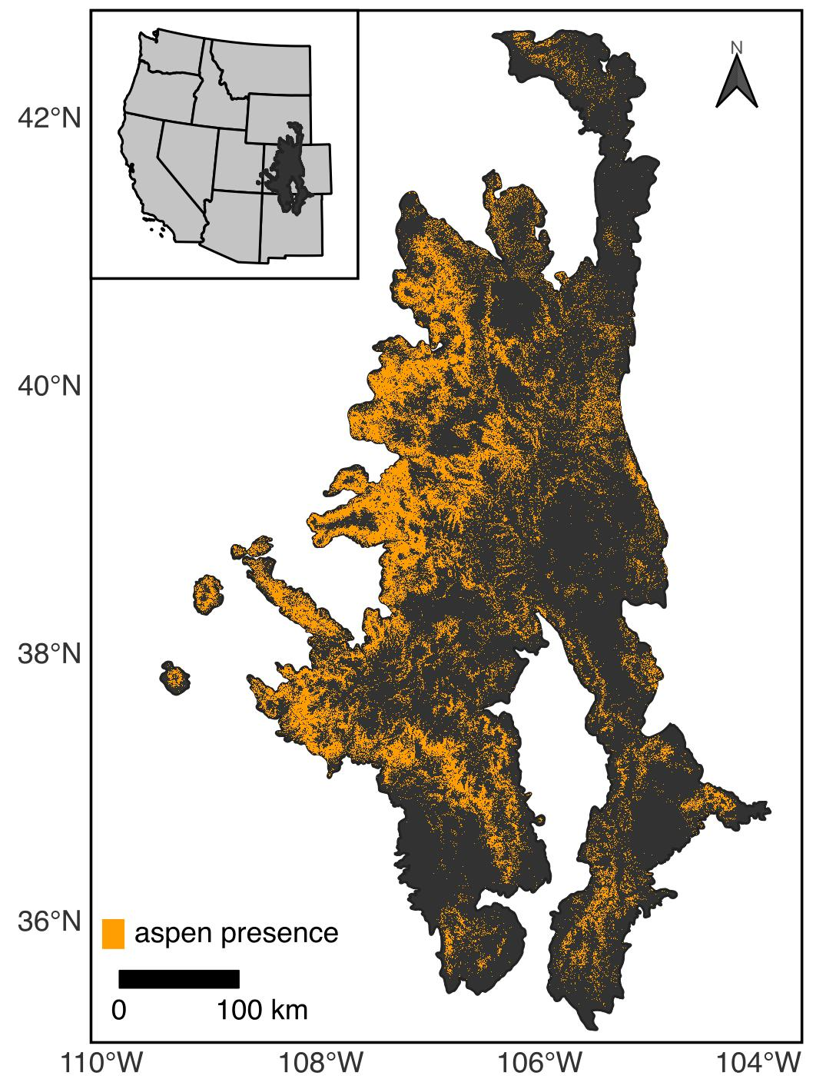

Figure 1: The Southern Rocky Mountain Ecoregion and current distribution of aspen.

## Data

### Species occurrence data

To build SDMs, we used a 10-m gridded map of aspen presence/absence produced by Cook et al. [in review]. Briefly, this dataset was produced by xyz. The map is characterized by an overall accuracy of XX and represents the distribution of aspen in ca. XXXX. To generate our SDMs, we aggregated the data from 10-m to 90-m, a scale relevant to management (Rehfeldt et al., 2015).

### Predictor variables

To understand how climate is related to the contemporary distribution of aspen and the potential for future climate change to drive range shifts, we obtained gridded climate data from the AdaptWest Project (2022). This dataset consists of both current and future climate data that are downscaled to 1 x 1 km resolution using the ClimateNA software (version 7.3) (Wang et al., 2016) . Contemporary climate conditions, defined here as climatalogical norms for the 1981-2010 period, were generated from 4 x 4 km climate data provided by the PRISM Climate Group (2021). Future climate conditions were generated from data included in the sixth phase of Coupled Model Intercomparison Project (CMIP6). Here we used projections of future climate for the periods 2011-2040, 2041-2070, and 2071-2100. Given considerable uncertainty about future emissions, we compared two scenarios (i.e., Shared Socioeconomic Pathways; SSPs) generated under CMIP6, SSP2-4.5 and SSP5-8.5. The SSP2-4.5 scenario describes an intermediate scenario characterized by moderate increases in emissions through 2040 followed by a decline, while the SSP5-8.5 scenario describes a more extreme situation where emissions increase through 2100 (Riahi et al., 2017). In addition to uncertainty about societal decisions about greenhouse gas emissions represented in the SSPs, variation exists among the more than 50 atmosphere-ocean general circulation models (AOGCMs) included in CMIP6. Because of differences in complexity, assumptions, and parameterization of AOGCMS, not all forecasts are equally useful for regional planning purposes. Here we make use of an ensemble dataset constructed from eight AOCGMs identified by Mahony et al. (2022) as being appropriate for regional applications in North America, such as species distribution modeling.

To characterize the climate space that aspen currently occupies, we examined 34 biologically-relevant climate variables commonly used in species distribution models (Table 4). Broadly, these variables characterize the temperature, precipitation, seasonality, and interactions between precipitation and temperature. To avoid collinearity between climate predictors, we calculated pairwise correlation coefficients. When |r|>0.75, we removed variables based on existing research (Table 4). Where evidence was similar, we used univariate random forest (RF) models to evaluate the potential explanatory power of each predictor. The resulting dataset consisted of six climate variables: (1) an annual dryness index (ADI), (2) growing season precipitation (GSP), (3) the ratio of GSP to degree days above 5 °C (GSPDD5), (4) the ratio of GSP to mean annual precipitation (PRATIO), (5) mean annual relative humidity (RH), and (6) the difference between the mean coldest month temperature and the mean warmest month temperature (TD) (Table 4).

Given mountainous areas such as the SRME are characterized high topoclimatic variation (Franklin et al., 2013), we further downscaled our selected climate variables from a 1 km resolution to a 250 m resolution using gradient and inverse distance squared (GIDS) interpolation (Flint and Flint, 2012; Nalder and Wein, 1998), following methods outlined in Rodman et al. (2020). As ancillary data in the downscaling, we used a digital elevation model (DEM) from the USGS (2023).

In addition to climate variables, we also included data describing terrain and soils as predictors in our models. To account for the potential effects of local topographic variation on soil transport and water balance (Jones and DeByle, 1985), we used a 30-m DEM from the USGS (2023) to calculate the topographic position index [TPI; Weiss (2001)]. We calculated TPI for a 3-cell neighborhood (TPI3) to characterize fine scale topographic patterns (Rodman et al., 2020). To account for the effects of aspect and slope on local climate, we calculated the Heat Load Index [HLI; McCune and Keon (2002); McCune (2007)]. Both HLI and TPI3 were calculated in R using the *spatialeco* package (Evans and Murphy, 2021). Given soil properties may influence aspen demographic processes (Jones and DeByle, 1985), we obtained 30-m probabilistic maps of soil pH, the percentage of organic material, the percentage of clay, and saturated soil water content from the POLARIS database (Chaney et al., 2019). We did not include elevation, latitude, and longitude as predictors in our modeling because we assumed these relationships were only correlative (Araújo et al., 2019). We re-sampled soil and topographic predictors to a 90-m resolution by calculating the mean and projected the data to Universal Transmercator (UTM) Zone 13N to match the maps of aspen occurrence.

Table 1: Predictor variables and . Variables marked with an asterisk were removed prior to model building to reduce collinearity among predictors.

| Variable | Description | Expected relationship with aspen |
| --- | --- | --- |
| ADI | annual dryness index: (degree-days above 5 °C)^0.5 / (mean annual precipitation) | Fast-growing, short-lived species such as aspen typiclaly have high water demand (Ireland et al. 2014). Thus high ADI has been linked with lower climate suitability for aspen (Rehfeldt et al. 2009, 2015). |
| DD_0 | degree-days below 0 °C | To prevent early devleopment of new buds that may lead to injury, aspen phenology is requires a chilling period. Insufficient chilling periods may delay budburst (Man et al. 2017). |
| GSP | growing season (Apr - Sep) precipitation (mm) | Greater precipitaiton during the growing season may alleviate summer moisture stresss (Worral et al. 2013). |
| GSPDD5 | growing season precipitation to degree day ratio: (GSP/DD5) | Seasonal moisture stress may be lower in locations with greater growning season precipitaiton and shorter a growing season (i.e., high GSPDD5) (Rehfeldt et al. 2009). |
| PRATIO | mean precipitation ratio: (growing season precipitation) / (mean annual precipitation) | Evenly distributed precipitation (intermediate PRATIO) may promote aspen by limiting seasonal moisture stress (Rehfeltd et al. 2009) |
| RH | mean annual relative humidity (%) | Lower relative humidity leads to greater water loss via transpiration. To limit this loss, trees may close their stomata and thereby limiting photosynthesis. |
| TD | difference between MCMT and MWMT (°C) | Extreme seaonal varaition in temperature may present physiological challenges to aspen (Worrall et al. 2013; Rehfeldt et al. 2015) |
| Clay | clay | High clay content may inhibit aspen growth (Jones and DeByle 1985) |
| OM | soil organic matter [log10(%)] | Aspen is expected grow better on soils with high organic matter content (Perala 1990) |
| SWC | saturated water content (m3/m3) | Aspen is expected grow better on soils with greater water holding capacity (Perala 1990). |
| HLI | heat load index | Greater HLI may inhibit aspen, particularly at lower elevations and latitudes (Jones et al. 1985). |
| TPI | topographic position index | Aspen is expected grow better in valley bottoms (low TPI) and on benches (moderate TPI) than steep slopes (high TPI), where soil water content may be lower (Jones and DeByle 1985) We calculated TPI using nioeighborhoods of 3 (TPI3) and 15 (TPI15), however we retained only TPI3 because of high correlation among the two indices. |

## Modeling Approach

### Overview

To characterize suitable habitat for aspen, we used four different modeling approaches commonly applied in species distribution modeling, generalized linear models (GLMs), generalized additive models (GAMS), and random forests (RFs), and regularized gradient boosted tree (RGBTs). Here, we first overview our modeling approach before describing specifics for individual modeling techniques. All models were fit in *R* (R Core Team, 2022) using a *tidymodels* framework (Kuhn and Wickham, 2020).

To build GLM, GAM, RF, and GBT models, we first constructed a balanced data consisting of 10,000 pixels with aspen present and 10,000 pixels without aspen. To minimize the potential effects of spatial autocorrelation, pixels were selected so that they were separated by at least 1 km. To improve model fit and interpretability, all predictor variables were standardized by calculating the z-score. Using this dataset, we reduced our set of environmental predictors to minimize the potential effects of collinearity on model inference and projection. Specifically, we used the *spatialRF* (Wright and Ziegler, 2017) to identify variables with a variable inflation factor greater than 5. When these conditions were met, variables we first retained climate variables based on a priori expectations (Table 4) and topoedaphic variables using VIF scores.

To build and evaluate models, we then split our dataset into equally-sized testing and training datasets. The testing dataset was further split to create five spatial cross-validation folds using the *spatialsample* package (Mahoney et al., 2023). We then tuned model hyperparameters using spatial cross-validation and identified the best hyperparameters based on the area under the receiver operator curve (AUC). To evaluate the capacity of our model to predict to new areas, we then fit the model using the best hyperparameters to each spatial cross-validation fold and assessed the variation in the AUC statistic. Given the model’s ability to predict aspen habitat in new areas, we then fit a final model to the training dataset and predicted the probabiliy of aspen presence for the testing dataset. Using the *probably* package (Kuhn et al., 2023), we determined the probability threshold that maximized the Youden’s J statistic (Youden, 1950) and then calculated class-based accuracy statistics based on this threshold.

To better understand the environmental drivers of aspen’s distribution and assess model realism, we calculated variable importance scores for each model using a model-agnostic permutation-based approach. In this approach each variable is randomized and then the AUC statistic is compared with AUC for the full model (where data has not been randomized). We also evaluated the relationship between aspen presence and each predictor variable using accumulated local effects (ALE) profiles (Apley and Zhu, 2020). Variable importance and ALE were calculated in R using the *DALEX* (Biecek, 2018) and *ALEPlot* (Apley, 2018) packages.

### Generalized linear models

GLMs are extensions of parametric linear regression adapted to distributions other than the normal distribution (Zuur et al., 2007). Here we used GLMs with a logit link function and a binomial error distribution to account for the structure of presence-absence data. We included both linear and quadratic effects for all variables, but did not explore any interaction terms. We fit GLMs using a Lasso regularization approach, which allows for model coefficients to be reduced to zero, thereby limiting model complexity and improving bias-variance tradeoffs (Hastie et al., 2009). Prior to fitting the model to the full training dataset, we used spatial cross-validation to tune the lasso penalty term. GLMs were fit using the *glmnet* package (Friedman et al., 2010).

### Generalized additive models

GAMs are a non-parametric extension of GLMs that are particularly useful when there is no *a priori* reason for fitting a particular relationship (e.g., linear, quadratic). Here, we construct binomial GAMs with a logit link function using the *mgcv* package (Wood, 2011). In our model, we represented the relationships between the response and each predictor variable using thin plate regression splines, where the penalty term was adjusted to allow the term to be shrunk to zero. For all smooths, we set the k parameter, which sets the number of basis functions, to the default value of 10, after using built in diagnostic function from the *mgcv* package to confirm an adequate degree of complexity. To limit overfitting, we used spatial cross-validation to tune the penalty term prior to fitting the model to the full training dataset. GAMs were fit using restricted maximum likelihood (REML), following recommendations from Pedersen et al. (2018).

### Random Forests

RF models are an extension of classification and regression tree analysis (CART; Breiman et al. (1984)), a nonparametric approach where decision trees are used to explain the variation in the response variable by repeatedly splitting the data into more similar groups (Death and Fabricius, 2000). Tree-based approaches are useful for modeling nonlinear relationships and complex interactions among variables, which often characterize ecological data (Cutler et al., 2007; Death and Fabricius, 2000). RF builds upon bagging methods, where many trees are built using random samples (with replacement) of the training data and predictions are generated from the ensemble set of trees. While bagging reduces some of the overfitting issues associated with CART, RF methods also limit the number of variables to consider at any given split to a random subset and the complexity of each tree by limiting splits to only nodes with a minimum number of data points. The inclusion of these hyperparameters results in less correlation among trees and thus better bias-variance tradeoffs (Cutler et al., 2007). Using spatial cross-validation, we tuned these hyperparameters, while holding the number of trees constant at 1000. RF models were fit using the tidymodels implementation of the *ranger* package (**ranger?**)

### Regularized gradient boosting trees

Gradient boosted trees (GBTs) are also an ensemble-based extension of CART (De’ath, 2007). In contrast to RF where trees are built in parallel, individual trees in a GBT ensemble are constructed iteratively so that each successive tree attempts to improve upon predictions made by the previous tree. To improve bias-variance tradeoffs, GBTs incorporate a hyperparameter that controls rate at which the boosting algorithm adapts. In addition, GBTs include hyperparameters that introduce randomness into the tree construction by sampling (1) variables for model building (i.e., incorporating an *mtry* hyperparameter) and (2) the number of cases used to fit the model (*sample_size*). RGBTs expand upon these approaches by incorporating regularization terms that constrain the depth of the tree and setting limits on the amount of gain in model fit required to further partition a node of the tree. Here we used spatial cross-validation to tune these hyperparameters. RGBTs were fit using the R package *xgboost* (Chen et al., 2023).

### Model Ensemble

To account for uncertainty due to modelling approach (Araujo and New, 2007), we generated ensemble predictions by combing predictions for each model. Specifically, we calculated a weighted probability of occurrence from all four presence-absence models. Weights assigned were based on the AUC statistic. We then comparing the ensemble prediction probability with the testing dataset and determined the probability threshold that maximized the Youden’s J statistic (Youden, 1950). We then used this threshold to calculate class-based accuracy statistics.

## Forcasting change in aspen habitat

To understand how future changes in climate may affect the distribution of aspen, we first used the ensemble model to forecast the probability of aspen habitat suitability under the SSP2-4.5 and SSP5-8.5 scenarios for the 2011-2040, 2041-2070, and 2071-2100 periods. We then used these probabilistic forecasts of aspen habitat suitability to forecast aspen presence and absence based on the optimal probability threshold identified herein. These maps were overlaid with the map of existing aspen occurrence from Cook et al. (in review) to produce maps where changes in climate may lead to aspen expansion, contraction, or remain stable. Finally, given expansion will be constrained by dispersal, for each pixels that was identified as a potential area of expansion we used a moving widow approach to calculate the distance to the nearest existing stand of aspen. Specifically, we quantified the presence of aspen with 3, 5, 7, 13, 25, and 47 cell neighborhoods (i.e., within 90 m, 180 m, 270 m, 540 m, 1080 m, and 2070 m).

# Results

## Model performance

Spatial cross-validation revealed all models accurately predicted to new areas; across the five folds the mean AUC statistic (± standard error of the mean) was 0.78 ± 0.02, 0.81 ± 0.01, 0.83 ± 0.01 0.83 ± 0.01, for the GLM, GAM, RF, and RGBT, respectively. When compared with the testing data, all models achieved an AUC greater than 0.8, indicating a good model fit (Table 2). Tree-based approaches were generally better than the GLM or GAM at predicting aspen presence (i.e., higher sensitivity), but were worse at predicting aspen absence (i.e. lower specif. Based on AUC, the ensemble model outperformed each individual model, however the improvement was minimal (Table 2). The ensemble model also correctly predicted 71% of points that aerial imagery interpreters identified as occupied by aspen (n=12470).

Table 2: Model performance statistics. Observed values are from independent testing data.

| Model | Accuracy | F measure | kappa | Precision | Recall | AUC | Sensitivity | Specificity |
| --- | --- | --- | --- | --- | --- | --- | --- | --- |
| Ensemble | 0.77 | 0.77 | 0.53 | 0.76 | 0.78 | 0.84 | 0.78 | 0.76 |
| GAM | 0.75 | 0.75 | 0.50 | 0.75 | 0.74 | 0.83 | 0.74 | 0.76 |
| GLM | 0.74 | 0.73 | 0.48 | 0.76 | 0.70 | 0.81 | 0.70 | 0.77 |
| RF | 0.72 | 0.75 | 0.45 | 0.69 | 0.81 | 0.81 | 0.81 | 0.64 |
| XGB | 0.73 | 0.75 | 0.46 | 0.69 | 0.82 | 0.82 | 0.82 | 0.64 |

While the ensemble model performed well, there were spatial patterns in the residuals (Figs. 2 - 3). Relative to true positives (i.e., pixels where aspen was present that were correctly classified), false negatives (i.e., pixels where aspen was absent but that were modeled to that were correctly classified) were concentrated at lower elevations and more eastern latitudes, while false positives occurred more frequently at higher elevations and more western latitudes. False negatives were common where the percent aspen cover within the 90 x 90 m pixel was low (median value of 11.1%).

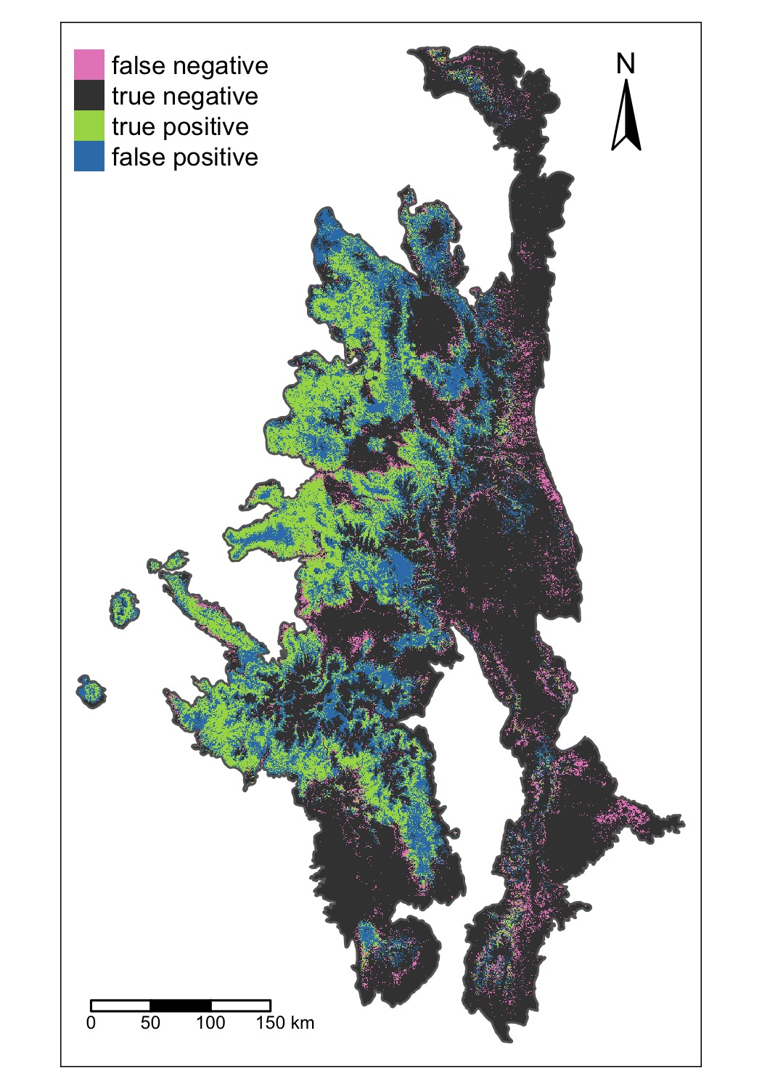

Figure 2: Spatial patterns of missclassification for the ensemble model.

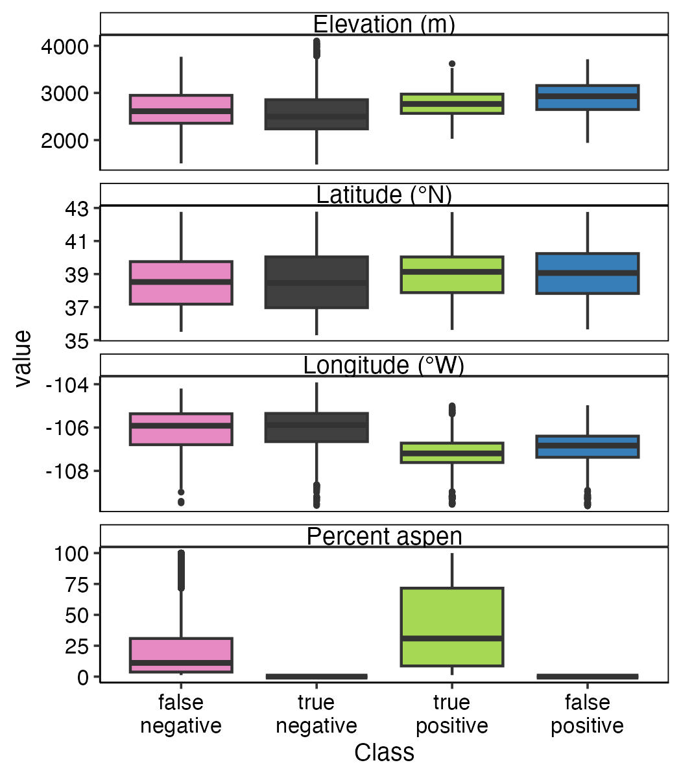

Figure 3: Boxplots illustrating the relationship between pixels missclassified and geographic variables and percent aspen cover.

## Effects of predictor variables on aspen habitat suitability

Variable importance scores revealed that climate variables generally contributed more to model fit than soil or topographic factors (Fig. 4A)). The regularization approaches we included in the GLM and GAM allowed for coefficient estimates to shrink to zero, leading to fewer variables driving the probability of aspen in these models. As a result, ADI and GSPDD5 contributed strongly to fit of the GAM, while ADI and PRATIO were key contributors to the fit of the GLM.

Across all models, ADI was on average the most important predictor of aspen presence (Fig. 4A). Across the area of the SRM currently occupied by aspen, ADI is forecasted to increase (i.e., become drier) over the next century (Fig. 4B). Most SDMs agreed that this shift would generally lead to a decrease in mean aspen habitat suitability. However, the GLM suggested that future increases in ADI may initially lead to an increase in mean aspen habitat suitability, followed by a decrease by 2071-2100.

Across all models, PRATIO was the second most important predictor of aspen presence (Fig. 4A). PRATIO is expected to decrease slightly across the study over the next 100 years (Fig. 4B). SDMs agree that this should on average lead to an increase in aspen habitat suitability across the SRM. However, for locations where PRATIO is already low, the GAM, RF, and RGBT models suggest this may decrease aspen habitat suitability.

GSPDD5 was identified as a particularly important predictor variable in the GAM. Across the study area GSPDD5 is expected to decrease over the next century, largely due to increases in temperature (Fig. 4B). Our SDMs suggest this may lead to a decrease, increase, or no change in mean aspen habitat suitability across the SRM. In the GAM GSPDD5 is negatively associated with aspen presence, while GSPDD5 had no effect in the GLM, and the relationship was more hump-shaped in RF and RGBT models.

All models suggested that aspen habitat suitability was higher in valley bottoms (low TPI3) than steep slopes (high TPI3), although RF and RGBT models suggested benches (moderate TPI3) may be equally suitable as steep slopes (Fig. 4B).

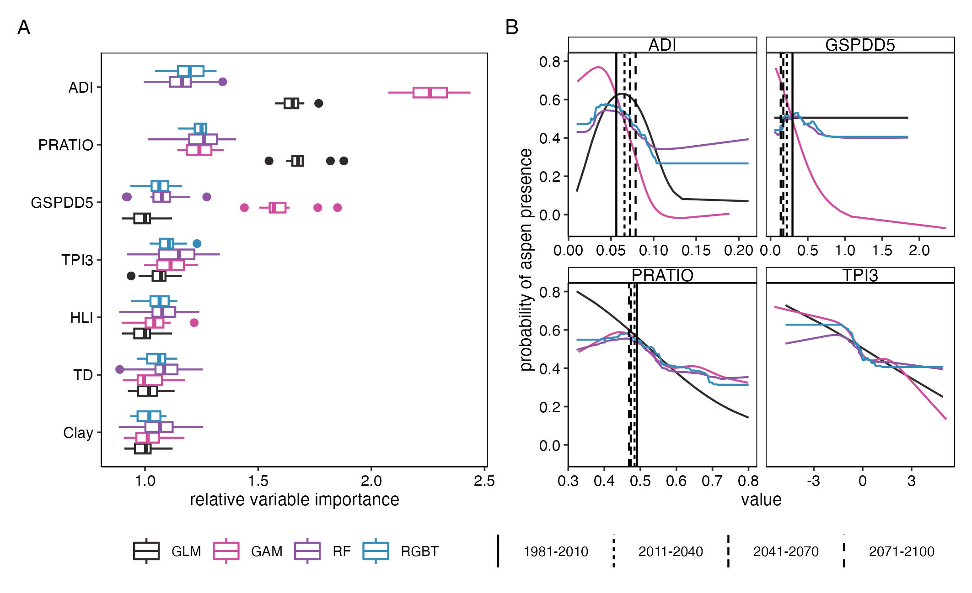

Figure 4: Variable importance scores (A) and accumulate local effects (B) for models of aspen habitat suitability by modeling approach. In A, boxes illustrate the loss in model performance (1-AUC) when the predcitor variable was been randomized for 10 different permutations. In B, vertical lines illustrate the mean climate conditions for areas with existing aspen for the historical period (1981-2010) and projections for the 2011-2040, 2041-2070, and 2071-2100 periods under the SPP4-8.5 scenario. For variable definitions and descriptions see Table 1.

## Forcasted change in aspen habitat suitability

Our ensemble SDM forecasts notable decreases in future aspen habit suitability with particularly dramatic decreases within the first half of the 21st century. Under the SSP2-4.5 scenario, the ensemble model suggests a percent change in the mean probability of aspen of -27.3 ± 18% by 2040 and -27.8 ± 24.7% by 2100. Under the SSP5-8.5 scenario, our model forecasts similar reductions the probability fo aspen ( -28.1 ± 18.5% by 2040 and -27.6 ± 31.7% by 2100).

Based on the 0.49 probability threshold for classifying aspen occurrence, which was selected based on Youden’s J statistic, our SDM suggests that these decreases in the aspen habitat suitability may result in the loss of aspen may across 15186 km2 under the SSP2-4.5 scenario and 16603 km2 under the SSP5-8.5 scenario by 2100 (Fig. 13). However, the decrease in the area suitable for aspen may be offset by increases in the area suitable for aspen. By 2100, the ensemble model suggests an increase in the area suitable for aspen of 17054 and 19774 km2 under the SSP2-4.5 and SSP5-8.5 scenarios, respectively. Across both scenarios and all time periods, losses in the area suitable for aspen are forecasted to occur at lower elevations and eastern latitudes, where aspen is already limited (Figs. 13- (**ref?**)(fig:LossGainBox)). Increases in the area suitable for aspen are forecasted to occur at higher elevations.

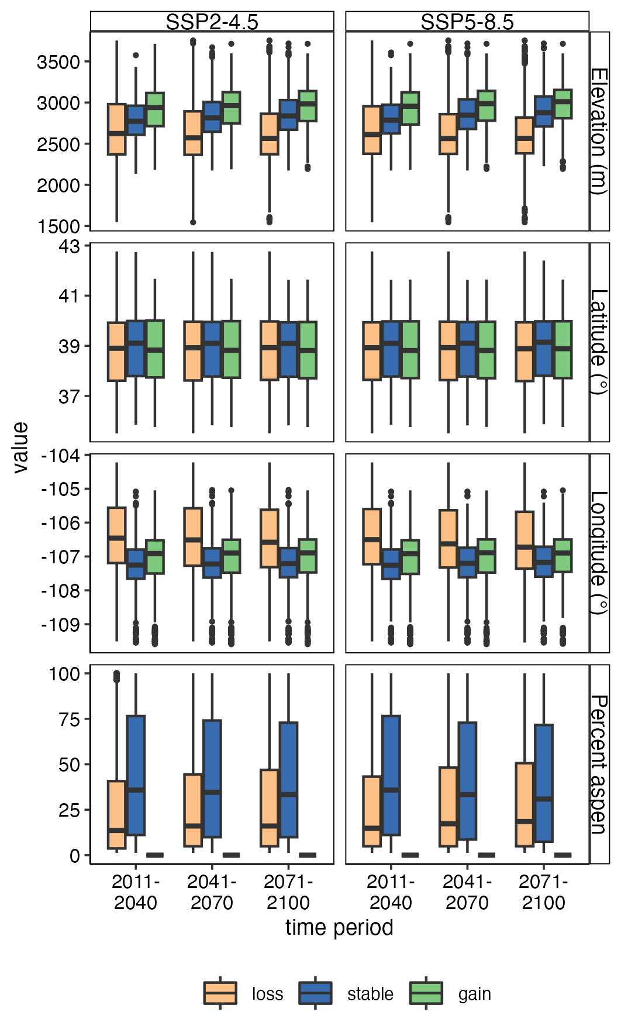

Figure 5: Boxplots illustrating the distribution of geographic

While the area suitable for aspen is expected to increases substantially, only a fraction of that area is near existing aspen stands (Fig. 6). Values were similar for both scenarios, so here we descrbine values for the SSP2-4.5 scenario, although data for both scenarios are presented in Fig. 6. Under the SSP4-2.5 scenario, % of the area forecasted to become suitable by 2071-2100 is within 90-m of existing aspen (Fig. 6), and 0 % of area is within 540-m of existing aspen.

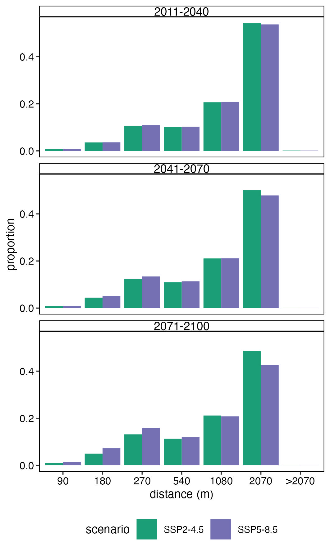

Figure 6: GainDistanceMaps

# Discussion

1. Overview of results
2. Discussion of comparison with previous research
   * climate
   * soils
   * topography
3. Limitations of modeling
   * environmental truncation (Hannemann et al., 2016; Thuiller et al., 2004)
4. Dispersal
5. Management implications

# Conclusions

# References

AdaptWest Project, 2022. [Gridded current and projected climate data for north america at 1km resolution, generated using the ClimateNA v7.30 software (t. Wang et al., 2022).](https://Available at adaptwest.databasin.org.)

Apley, D., 2018. [ALEPlot: Accumulated local effects (ALE) plots and partial dependence (PD) plots](https://CRAN.R-project.org/package=ALEPlot).

Apley, D.W., Zhu, J., 2020. Visualizing the effects of predictor variables in black box supervised learning models. Journal of the Royal Statistical Society: Series B (Statistical Methodology) 82, 1059–1086. <https://doi.org/10.1111/rssb.12377>

Araujo, M., New, M., 2007. Ensemble forecasting of species distributions. Trends in Ecology & Evolution 22, 42–47. <https://doi.org/10.1016/j.tree.2006.09.010>

Araújo, M.B., Anderson, R.P., Márcia Barbosa, A., Beale, C.M., Dormann, C.F., Early, R., Garcia, R.A., Guisan, A., Maiorano, L., Naimi, B., O’Hara, R.B., Zimmermann, N.E., Rahbek, C., 2019. Standards for distribution models in biodiversity assessments. Science Advances 5, eaat4858. <https://doi.org/10.1126/sciadv.aat4858>

Baker, W.L., Veblen, T.T., 1990. Spruce beetles and fires in the nineteenth-century subalpine forests of western colorado, USA. Arctic and Alpine Research 22, 6580.

Biecek, P., 2018. [DALEX: Explainers for complex predictive models in r](https://jmlr.org/papers/v19/18-416.html) 19, 1–5.

Bradley, B.A., Mustard, J.F., 2006. Characterizing The Landscape Dynamics Of An Invasive Plant And Risk Of Invasion Using Remote Sensing. Ecological Applications 16, 1132–1147. <https://doi.org/10.1890/1051-0761(2006)016[1132:CTLDOA]2.0.CO;2>

Breiman, L., Friedman, J.H., Olshen, R.A., Stone, C.G., 1984. Classification and regression trees. Belmont, CA, USA. <https://doi.org/10.1201/9781315139470>

Chaney, N.W., Minasny, B., Herman, J.D., Nauman, T.W., Brungard, C.W., Morgan, C.L.S., McBratney, A.B., Wood, E.F., Yimam, Y., 2019. POLARIS Soil Properties: 30-m Probabilistic Maps of Soil Properties Over the Contiguous United States. Water Resources Research 55, 2916–2938. <https://doi.org/10.1029/2018WR022797>

Chapman, T.B., Veblen, T.T., Schoennagel, T., 2012. Spatiotemporal patterns of mountain pine beetle activity in the southern rocky mountains. Ecology 93, 2175–2185. <https://doi.org/10.1890/11-1055.1>

Chen, T., He, T., Benesty, M., Khotilovich, V., Tang, Y., Cho, H., Chen, K., Mitchell, R., Cano, I., Zhou, T., Li, M., Xie, J., Lin, M., Geng, Y., Li, Y., Yuan, J., 2023. [Xgboost: Extreme gradient boosting](https://CRAN.R-project.org/package=xgboost).

Comer, P., 2001. Southern rocky mountains: An ecoregional assessment and conservation blueprint.

Cutler, D.R., Edwards Jr, T.C., Beard, K.H., Cutler, A., Hess, K.T., Gibson, J., Lawler, J.J., 2007. Random forests for classification in ecology. Ecology 88, 27832792.

De’ath, G., 2007. Boosted Trees for Ecological Modeling and Prediction. Ecology 88, 243–251. <https://doi.org/10.1890/0012-9658(2007)88[243:BTFEMA]2.0.CO;2>

Death, G., Fabricius, K.E., 2000. [Classification and regression trees: A powerful yet simple technique for ecological data analysis](http://www.esajournals.org/doi/pdf/10.1890/0012-9658(2000)081%5B3178:CARTAP%5D2.0.CO%3B2). Ecology 81, 31783192.

Drummond, M.A., 2012. [Southern rockies ecoregion: Chapter 8 in status and trends of land change in the western united states–1973 to 2000](http://pubs.er.usgs.gov/publication/pp1794A8). Reston, VA.

Evans, J.S., Murphy, M.A., 2021. [spatialEco](https://github.com/jeffreyevans/spatialEco).

Flint, L.E., Flint, A.L., 2012. Downscaling future climate scenarios to fine scales for hydrologic and ecological modeling and analysis. Ecological Processes 1, 2. <https://doi.org/10.1186/2192-1709-1-2>

Franklin, J., Davis, F.W., Ikegami, M., Syphard, A.D., Flint, L.E., Flint, A.L., Hannah, L., 2013. Modeling plant species distributions under future climates: how fine scale do climate projections need to be? Global Change Biology 19, 473–483. <https://doi.org/10.1111/gcb.12051>

Friedman, J., Tibshirani, R., Hastie, T., 2010. Regularization paths for generalized linear models via coordinate descent 33. <https://doi.org/10.18637/jss.v033.i01>

Hannemann, H., Willis, K.J., Macias-Fauria, M., 2016. The devil is in the detail: unstable response functions in species distribution models challenge bulk ensemble modelling. Global Ecology and Biogeography 25, 26–35. <https://doi.org/10.1111/geb.12381>

Hart, S.J., Veblen, T.T., Eisenhart, K.S., Jarvis, D., Kulakowski, D., 2014. Drought induces spruce beetle (dendroctonus rufipennis) outbreaks across northwestern colorado. Ecology 95, 930939.

Hastie, T., Tibshirani, R., Friedman, J.H., Friedman, J.H., 2009. The elements of statistical learning: Data mining, inference, and prediction. Springer.

He, K.S., Bradley, B.A., Cord, A.F., Rocchini, D., Tuanmu, M.-N., Schmidtlein, S., Turner, W., Wegmann, M., Pettorelli, N., 2015. Will remote sensing shape the next generation of species distribution models? Remote Sensing in Ecology and Conservation 1, 4–18. <https://doi.org/10.1002/rse2.7>

Jones, J.R., DeByle, N.V., 1985. [Soils](https://www.fs.usda.gov/research/treesearch/27780). In: DeByle, Norbert V.; Winokur, Robert P., editors. Aspen: Ecology and management in the western United States. USDA Forest Service General Technical Report RM-119. Rocky Mountain Forest and Range Experiment Station, Fort Collins, Colo. p. 65-70 119.

Kuhn, M., Vaughan, D., Ruiz, E., 2023. [Probably: Tools for post-processing class probability estimates](https://CRAN.R-project.org/package=probably).

Kuhn, M., Wickham, H., 2020. [Tidymodels: A collection of packages for modeling and machine learning using tidyverse principles.](https://www.tidymodels.org)

Lukas, J., Barsugli, J., Doesken, N., Rangwala, I., Wolter, K., 2014. Climate change in colorado: A synthesis to support water resources management and adaptation. University of Colorado, Boulder, Colorado.

Mahoney, M.J., Johnson, L.K., Silge, J., Frick, H., Kuhn, M., Beier, C.M., 2023. Assessing the performance of spatial cross-validation approaches for models of spatially structured data. <https://doi.org/10.48550/arXiv.2303.07334>

Mahony, C.R., Wang, T., Hamann, A., Cannon, A.J., 2022. A global climate model ensemble for downscaled monthly climate normals over North America. International Journal of Climatology 42, 5871–5891. <https://doi.org/10.1002/joc.7566>

McCune, B., 2007. [Improved estimates of incident radiation and heat load using non-parametric regression against topographic variables](https://www.jstor.org/stable/4499284). Journal of Vegetation Science 18, 751–754.

McCune, B., Keon, D., 2002. [Equations for potential annual direct incident radiation and heat load](https://www.jstor.org/stable/3236745). Journal of Vegetation Science 13, 603–606.

Nalder, I.A., Wein, R.W., 1998. Spatial interpolation of climatic Normals: test of a new method in the Canadian boreal forest. Agricultural and Forest Meteorology 92, 211–225. <https://doi.org/10.1016/S0168-1923(98)00102-6>

Pedersen, E.J., Miller, D.L., Simpson, G.L., Ross, N., 2018. Hierarchical generalized additive models: an introduction with mgcv. <https://doi.org/10.7287/peerj.preprints.27320v1>

Peet, R.K., 1981. Forest vegetation of the colorado front range. Vegetatio 45, 375.

PRISM Climate Group, 2021. [Monthly 30-year climate normals (1981-2010)](https://prism.oregonstate.edu/normals/).

R Core Team, 2022. [R: A language and environment for statistical computing](http://www.R-project.org). R Foundation for Statistical Computing, Vienna, Austria.

Rehfeldt, G.E., Worrall, J.J., Marchetti, S.B., Crookston, N.L., 2015. Adapting forest management to climate change using bioclimate models with topographic drivers. Forestry. doi: 10.1093/forestry/cpv019. <https://doi.org/10.1093/forestry/cpv019>

Riahi, K., Vuuren, D.P. van, Kriegler, E., Edmonds, J., O’Neill, B.C., Fujimori, S., Bauer, N., Calvin, K., Dellink, R., Fricko, O., Lutz, W., Popp, A., Cuaresma, J.C., Kc, S., Leimbach, M., Jiang, L., Kram, T., Rao, S., Emmerling, J., Ebi, K., Hasegawa, T., Havlik, P., Humpenöder, F., Da Silva, L.A., Smith, S., Stehfest, E., Bosetti, V., Eom, J., Gernaat, D., Masui, T., Rogelj, J., Strefler, J., Drouet, L., Krey, V., Luderer, G., Harmsen, M., Takahashi, K., Baumstark, L., Doelman, J.C., Kainuma, M., Klimont, Z., Marangoni, G., Lotze-Campen, H., Obersteiner, M., Tabeau, A., Tavoni, M., 2017. The shared socioeconomic pathways and their energy, land use, and greenhouse gas emissions implications: An overview. Global Environmental Change 42, 153–168. <https://doi.org/10.1016/j.gloenvcha.2016.05.009>

Rodman, K.C., Andrus, R.A., Butkiewicz, C.L., Chapman, T.B., Gill, N.S., Harvey, B.J., Kulakowski, D., Tutland, N.J., Veblen, T.T., Hart, S.J., 2021. Effects of bark beetle outbreaks on forest landscape pattern in the Southern Rocky Mountains, U.S.A. Remote Sensing 13, 1089. <https://doi.org/10.3390/rs13061089>

Rodman, K.C., Veblen, T.T., Battaglia, M.A., Chambers, M.E., Fornwalt, P.J., Holden, Z.A., Kolb, T.E., Ouzts, J.R., Rother, M.T., 2020. A changing climate is snuffing out post-fire recovery in montane forests. Global Ecology and Biogeography geb.13174. <https://doi.org/10.1111/geb.13174>

Thuiller, W., Brotons, L., Araújo, M.B., Lavorel, S., 2004. Effects of restricting environmental range of data to project current and future species distributions. Ecography 27, 165–172. <https://doi.org/10.1111/j.0906-7590.2004.03673.x>

U. S. Geological Survey, 2023. [USGS 3D elevation program digital elevation model](https://elevation.nationalmap.gov/arcgis/rest/services/3DEPElevation/ImageServer.).

Veblen, T.T., Hadley, K.S., Nel, E.M., Kitzberger, T., Reid, M., Villalba, R., 1994. Disturbance regime and disturbance interactions in a rocky mountain subalpine forest. Journal of Ecology 82, 125–135. <https://doi.org/10.2307/2261392>

Veblen, T.T., Kitzberger, T., Donnegan, J., 2000. Climatic and Human Influences on Fire Regimes in Ponderosa Pine Forests in the Colorado Front Range. Ecological Applications 10, 1178–1195. https://doi.org/<https://doi.org/10.1890/1051-0761(2000)010[1178:CAHIOF]2.0.CO;2>

Wang, T., Hamann, A., Spittlehouse, D., Carroll, C., 2016. Locally Downscaled and Spatially Customizable Climate Data for Historical and Future Periods for North America. PLOS ONE 11, e0156720. <https://doi.org/10.1371/journal.pone.0156720>

Weiss, A., 2001. Topographic position and landforms analysis.

Wood, S.N., 2011. Fast stable restricted maximum likelihood and marginal likelihood estimation of semiparametric generalized linear models 73, 3–36.

Wright, M.N., Ziegler, A., 2017. Ranger: A fast implementation of random forests for high dimensional data in c++ and r 77. <https://doi.org/10.18637/jss.v077.i01>

Youden, W.J., 1950. Index for rating diagnostic tests. Cancer 3, 32–35. <https://doi.org/10.1002/1097-0142(1950)3:1<32::AID-CNCR2820030106>3.0.CO;2-3>

Zurell, D., Franklin, J., König, C., Bouchet, P.J., Dormann, C.F., Elith, J., Fandos, G., Feng, X., Guillera-Arroita, G., Guisan, A., Lahoz-Monfort, J.J., Leitão, P.J., Park, D.S., Peterson, A.T., Rapacciuolo, G., Schmatz, D.R., Schröder, B., Serra-Diaz, J.M., Thuiller, W., Yates, K.L., Zimmermann, N.E., Merow, C., 2020. A standard protocol for reporting species distribution models. Ecography 43, 1261–1277. <https://doi.org/10.1111/ecog.04960>

Zuur, A.F., Ieno, E.N., Smith, G.M., 2007. Analysing ecological data, Statistics for biology and health. Springer, New York ; London.

# Appendix A: ODMAP

## Overview

Here we describe the SDMs produced herein following the Overview, Data, Model, Assessment, Prediction (ODMAP) protocol for species distribution models (Zurell et al., 2020). Here, we first provide the Overview for our modeling, while the remaining ODMAP sections are detailed in Table S3.

The objectives of this modelling exercise are to (1) better explain the drivers of aspen’s distribution across the Southern Rocky Mountains, (2) map the area suitable for aspen, and (3) forecast the area suitable for aspen presence in the future under two different climate scenarios.

Table 3: ODMAP protocol information. Details on Data, Model, Assessment, Prediction. For Overview section, please refer to main text.

| ODMAP element | Contents |
| --- | --- |
| Overview |  |
| Authorship | Authors: Sarah J. Hart, Asha Paudel, Maxwell Cook |
|  | Contact email: sarah.hart@colostate.edu |
|  | Title: |
|  | DOI: |
| Model objective | Objective: Inference, Mapping, and Forecasting |
|  | Target outputs: continuous occurrence probabilities, binary maps of potential presence, and maps of potential loss, gain, and stable habitat |
| Taxon | Quaking aspen (Populus tremuloides) |
| Location | Southern Rocky Mountains, US |
| Scale of analysis | Spatial extent (Lon/Lat): Longitude 103.86 ° W - 109.61 ° W, Latitude 35.28 ° N - 47.78 ° N |
|  | Spatial resolution: 90 x 90 m |
|  | Temporal resolution and extent: We modelled the presence of aspen based on remotely sensed maps generated from imagery collected in XXXX |
|  | Type of extent boundary: ecoregion (Southern Rocky Mountains) |
| Biodiversity data overview | Observation type: remotely sensed |
|  | Response type: presence/absence |
| Type of predictors | Climatic, topographic, edaphic |
| Conceptual model / Hypotheses | Based on previous studies, we tested climate, topography and edaphic factors as important environmental predictor variables for aspen presence in the Southern Rocky Mountains. For detailed hypotheses, see Table 1. |
| Assumptions | We make the following key assumptions:  (1) aspen is at pseudo-equilibrium with the environment  (2) topography, climate, and soil conditions are the key drivers of aspen's distribution  (3) classification error (estimated at XX) in maps of aspen occurrence were negligible  (4) the relationship fit under current conditions apply to future climate conditions (i.e., no change in key limiting processes) |
| SDM algorithms | Algorithms: SDMs were fit using four different algorithms: generalized linear models (GLMs), generalized additive models (GAMs), regularized gradient boosted trees (RGBTs), and random forests (RFs). |
|  | Model complexity: We chose different modelling parameters to optimize each statistical technique. |
|  | Ensembles: We combined the four SDMs to generate an ensemble prediction |
| Model workflow | Prior to model building, all predictor variables were standardized. Model hyperparemeters were then tuned using a spatial cross-validation approach, with the best parameters selected using the area under the reciever operating chracteristic curve (AUC). |
| Software | Software: All analyses were conducted using R version 4.3.1 (R Core Team 2023) with the packages XXX, XXX, XXX |
|  | Code availability: All code is publicly available on GitHub (LINK) |
|  | Data availability: Data are available from XXXX |
| Data |  |
| Biodiversity data | Taxon names: Trembling aspen (Populus tremuloides) |
|  | Taxonomic reference system: US Department of Agriculture (USDA) Plant List of Attributes, Names, Taxonomy, and Symbols (PLANTS) Database |
|  | Ecological level: population |
|  | Data source: Aspen presence-absence data at 10x10 m spatial resolution were obtained from Cook et al. (in review). |
|  | Sampling design: |
|  | Sample size: The aspen dataset consists of 4,312,302,640 10 x 10 m cells, of which 117,140,964 recorded the presence of aspen. |
|  | Ecoregion mask: We clipped all data to the Southern Rocky Mountain Ecoregion using data from the EPA's (2013) Level III Ecoregions of the Conterminous United States product. |
|  | Scaling: We aggregated the aspen presence-absence data to a 90 x 90 m cell size. |
|  | Data filtering: |
|  | Absence data: The Cook et al. (in review) map consists of both presence and absence data. |
| Data partitioning | To reduce computation time, we randomly selected 10,000 cells for model building and 10,000 cells model testing. To reduce the potential effects of spatial autocorrelation, all sample points were separated by a distance of at least 1 km. |
| Environmental data/predictor varaibles | Predictor variables:  (1) Topography: topographic position index, heat load index (HLI)  (2) Climate: 35 climate variables (see Table XX)  (3) Soils: percent clay, percent soil organic matter, saturated water content |
|  | Data sources:  (1) Topography: 3DEP DEM (USGS XXX).  (2) Climate: AdaptWest Project (2022)  (3) Soils: POLARIS soil properties database (Cheney et al. 2019). |
|  | Spatial resolution and extent of raw data: All data were available for the entire study area.  (1) Topography: The raw resolution of the topographic data was 30 m.  (2) Climate: The raw resolution of the topographic data was 1 km.  (3) Soils: The raw resolution of the topographic data was 30 m. |
|  | Temporal resolution and extent of raw data:  (1) Topography: raw topographic data were collected over the period 2009-2023  (2) Climate: mean monthly climate data the period 1981-2010  (3) Soils: integrate data collected over the 1899 to 2019 period as part of the National Cooperative Soil Survey |
|  | Geographic projection of raw data:  (1) Topography: NAD83(HARN) / Conus Albers (EPSG:5071)  (2) Climate: Lambert Azimuthal Equal Area (EPSG:9820)  (3) Soils: WGS 84 (EPSG:4326) |
|  | Data processing: (1) Topography: We cacluated the Heat Load Index (HLI) and topographic position index (TPI) using the spatialeco package (REF). TPI was calculated using a 3 cell neighborhood (i.e. 90 x 90 m) and a 15 cell neighborhood (i.e. 450 x 450 m). TPI and HLI datasets were then aggregated to 90 m using the mean value and reprojected to Universal Transmercator (UTM) Zone 13N.  (2) Climate: We calculated ADI, GSP, PRATIO, and GSPDD5 following Rehfeldt et al. (2009). All climate varaibles were then downscaled to 250 m resolution using gradient and inverse distance squared (GIDS) interpolation.  (3) Soils: Soil data were aggregated to 90 m using the mean value and reprojected to Universal Transmercator (UTM) Zone 13N. |
| Model |  |
| Variable pre-selection | We initially reduced our set of climate predictor variables by first calcuating pairiwise Spearman's correlations and then fitting univriate random forest models of the presence/absenece using raw climate data (i.e., 1 km resoltuion not the 250 m downscaled product). When |r|>0.75, we retained the variable with greatest contribution to AUC, calcuated from the univariate model. |
| Multicollinearity | Using the downscaled climate varibles, we reduced multicollinearity in our predictor dataset by calculating variable inflation factors (VIF). When VIF >5, variables were iteratively removed, giving preference to climate variables (ordered by contribution to AUC from the univariate RF model) using the spatialRF package (Benito 2022). |
| Model settings | (1) The GLM was fit using a logit link function and a binomial error distribution. For all variables, we included both linear and quadratic effects. Models were fit using a Lasso regularization approach. The only tuned the penalty factor. Based on the higest AUC, the penalty factor was set to XX. We did not explore any interaction terms.  (2) The GAM was was fit using a logit link function and a binomial error distribution. For all variables, we used thin plate regression splines as the smooth basis and set bias demensions term (k) to the default value of 10. To prevent overfitted, we allowed We tuned the moothness adjust Models were fit using restricted maximum likelihood (REML). We did not explore any interaction terms.  (3) For the RF model, we tuned the minimum number of data points in a node that is required for the node to be split further (min_n) and the number of variables to try at each split (mtry). Based on highest AUC, min_n = XXX an//d mtry = XXX.  (3) GBT: For the GBT model, we tuned the minimum number of data points in a node that is required for the node to be split further (min_n), the reduction in the loss function required to split further (loss_reduction), the learning rate (learn_rate) and the maximum depth of the tree (tree_depth). Based on highest AUC, min_n = XXX, loss_reduction = XXX , learn_rate = XXX , and tree_depth = XXX. |
| Model estimates | Using the R package DALEX (REF), we determined variable importance using a model-angostic permutation-based approach. In this approach, each variable is randomized and then the ROC AUC statistic is compared with ROC AUC for the full model (where data has not been randomized). We evaluated the relationship between aspen presene and each predictor variabele using accumulated local effects (ALE) profiles, which were generated using the ingrediates package (REF). |
| Model averaging / Ensembles | We calculated a weighted probabilty of occurrence from all three presence-absence models. Weights assigned were based on the ROC AUC statistic. |
| Non-independence | We evaulated the potenital effects of spatial autocorrelation on our models' predictive ability using a spatially clustered cross-validation approach. |
| Threshold selection | Binary predictions were derived by maximizing Youden's J statistic, which balances sensitivity and specificty (Youden 1950). |
| Assessment |  |
| Performance statistics | Predictive model performancWe on validation data was assessed using X different performance measures: area under the reciever opperator curve (AUC), sensitivity, specificity, overall accuracy, kappa, F measure, Precision, and Recall |
| Plausibility checks | We checked model plausibility by assessing accumulated local effects plots. |
| Prediction |  |
| Prediction output | For further analyses, we used continuous predictions of occurrence probability, as well as predicted presence-absence, which was obtained by binarising the predicted occurrence probabilities using the TSS-maximization threshold. |
| Uncertainty quantification | We account for algorithmic uncertainty by applying an ensemble approach averaging over three different SDM algorithms. |

# Appendix B: Collinearity

Table 4: Climate variables considered for inclusion in SDMs and modeling notes.

| Variable | Description | Variable importance | Order | Modeling notes |
| --- | --- | --- | --- | --- |
| ADI | annual dryness index: (DD5^0.5)/MAP | 0.48 | 1 | retain - identified as important predictor by Rehfeldt et al. (2009) and (2015). |
| PRATIO | mean precipitation ratio:  GSP/MAP | 0.46 | 2 | retain - identified as important predictor by Rehfeldt et al. (2009) |
| DD5 | degree-days above 5 °C | 0.36 | 3 | remove - identified as important predictor by Worrall et al. (2013) and Greer et al. (2016, but high correlation (r≥0.75) with ADI |
| TMAX | Mean maximum temperature in warmest month | 0.21 | 4 | removed - identified as important predictor by Rehfeldt et al. (2009), Worrall et al. (2013), and Greer et al. (2016), but highly correlated (r≥0.75) with ADI |
| GSPDD5 | growing season precipitation to degree day ratio: (GSP/DD5) | 0.46 | 5 | retain - identified as important predictor by Rehfeldt et al. (2009) |
| MAP | mean annual precipitation (mm) | 0.35 | 6 | removed - Identified as important predictor by Worrall et al. (2013), but high correlation (r≥0.75) with ADI |
| PPT_wt | mean winter precipitation (mm) | 0.32 | 7 | removed - identified as important predictor by Worrall et al. (2013), but highly correlated (r≥0.75) with ADI |
| GSP | growing season (Apr - Sep) precipitation (mm) | 0.23 | 8 | retain - Idenified as important predictor by Worrall et al. (2013) |
| MWMT | mean warmest month temperature (°C) | 0.20 | 9 | removed - identified as important predictor by Rehfeldt et al. (2015), but high correlation (r≥0.75) with ADI |
| TD | difference between MCMT and MWMT (°C) | 0.18 | 10 | retain - identified as important predictor by Rehfeldt et al. (2015) and Worrall et al. (2013) |
| CMI | Hogg’s climate moisture index (mm) | 0.45 | 11 | remove - high correlation (r≥0.75) with ADI |
| DD_18 | degree-days below 18 °C | 0.40 | 12 | remove - high correlation (r≥0.75) with ADI |
| PAS | mean precipitation as snow (mm) between August in previous year and July in current year | 0.35 | 13 | remove - high correlation (r≥0.75) with ADI |
| PPT_at | mean autumn precipitation (mm) | 0.34 | 14 | remove - high correlation (r≥0.75) with ADI |
| DD_0 | degree-days below 0 °C | 0.31 | 15 | retain |
| DD1040 | degrees-days above 10 °C and below 40 °C | 0.31 | 16 | remove - high correlation (r≥0.75) with ADI |
| CMD | Hargreaves climatic moisture deficit (mm) | 0.30 | 17 | remove - high correlation (r≥0.75) with ADI |
| Eref | Hargreave's reference evapotranspiration (mm) | 0.28 | 18 | remove - high correlation (r≥0.75) with ADI |
| PPT_sp | mean spring precipitation (mm) | 0.28 | 19 | remove - high correlation (r≥0.75) with ADI |
| MCMT | mean coldest month temperature (°C) | 0.24 | 20 | remove - high correlation (r≥0.75) with DD_0 |
| DD18 | degree-days above 18 °C | 0.23 | 21 | remove - high correlation (r≥0.75) with DD_0 |
| MAT | mean annual temperature | 0.23 | 22 | remove - high correlation (r≥0.75) with ADI |
| Tave_wt | mean winter temperature (°C) | 0.23 | 23 | remove - high correlation (r≥0.75) with DD_0 |
| Tave_sm | mean summer temperature (°C) | 0.22 | 24 | remove - high correlation (r≥0.75) with ADI |
| Tave_sp | mean spring temperature (°C) | 0.22 | 25 | remove - high correlation (r≥0.75) with ADI |
| EMT | extreme minimum temperature (°C) | 0.21 | 26 | remove - high correlation (r≥0.75) with DD_0 |
| Tave_at | mean autumn temperature (°C) | 0.21 | 27 | remove - high correlation (r≥0.75) with ADI |
| bFFP | Julian date on which the frost free period beings | 0.20 | 28 | remove - high correlation (r≥0.75) with ADI |
| NFFD | mean annual number of frost free days | 0.20 | 29 | remove - high correlation (r≥0.75) with DD_0 |
| EXT | extreme maximum temperature (°C) | 0.20 | 30 | remove - high correlation (r≥0.75) with ADI |
| FFP | mean annual length of the frost-free period (days) | 0.19 | 31 | remove - high correlation (r≥0.75) with DD_0 |
| PPT_sm | mean summer precipitation (mm) | 0.17 | 32 | remove - high correlation (r≥0.75) with TD |
| eFFP | Julian date on which the frost free period ends | 0.16 | 33 | remove - high correlation (r≥0.75) with DD_0 |
| RH | mean annual relative humidity (%) | 0.09 | 34 | retain |

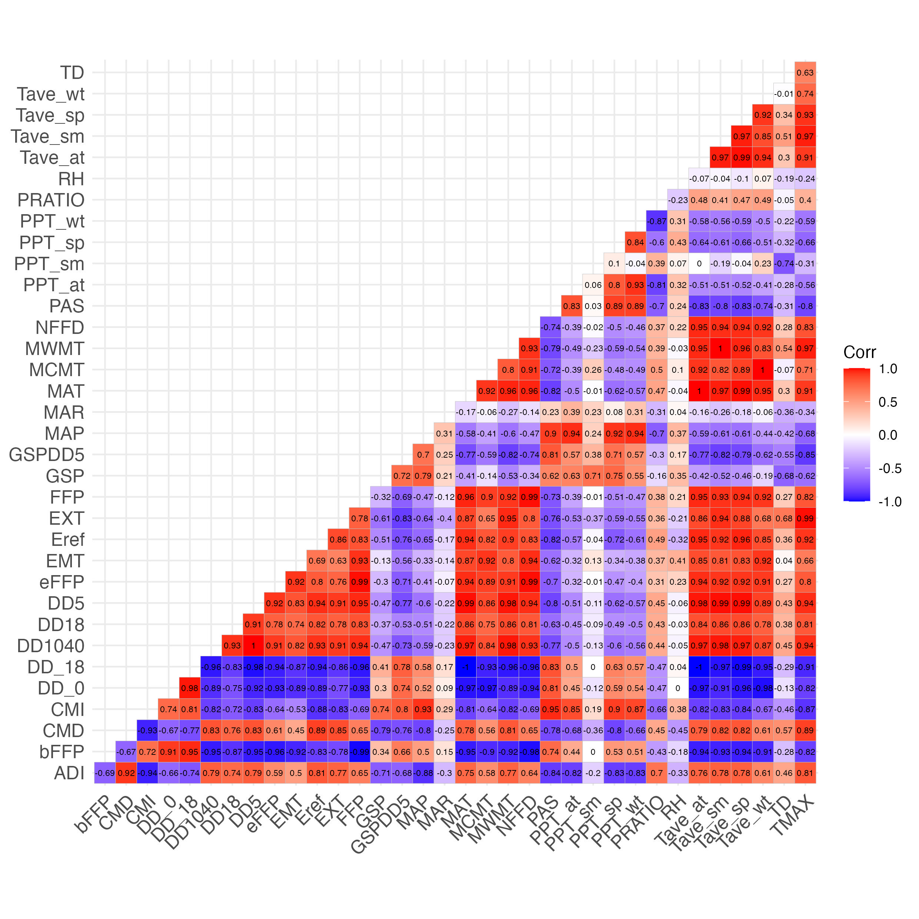

Figure 7: Spearman’s correlation coefficients between pairs of climate predictor variables

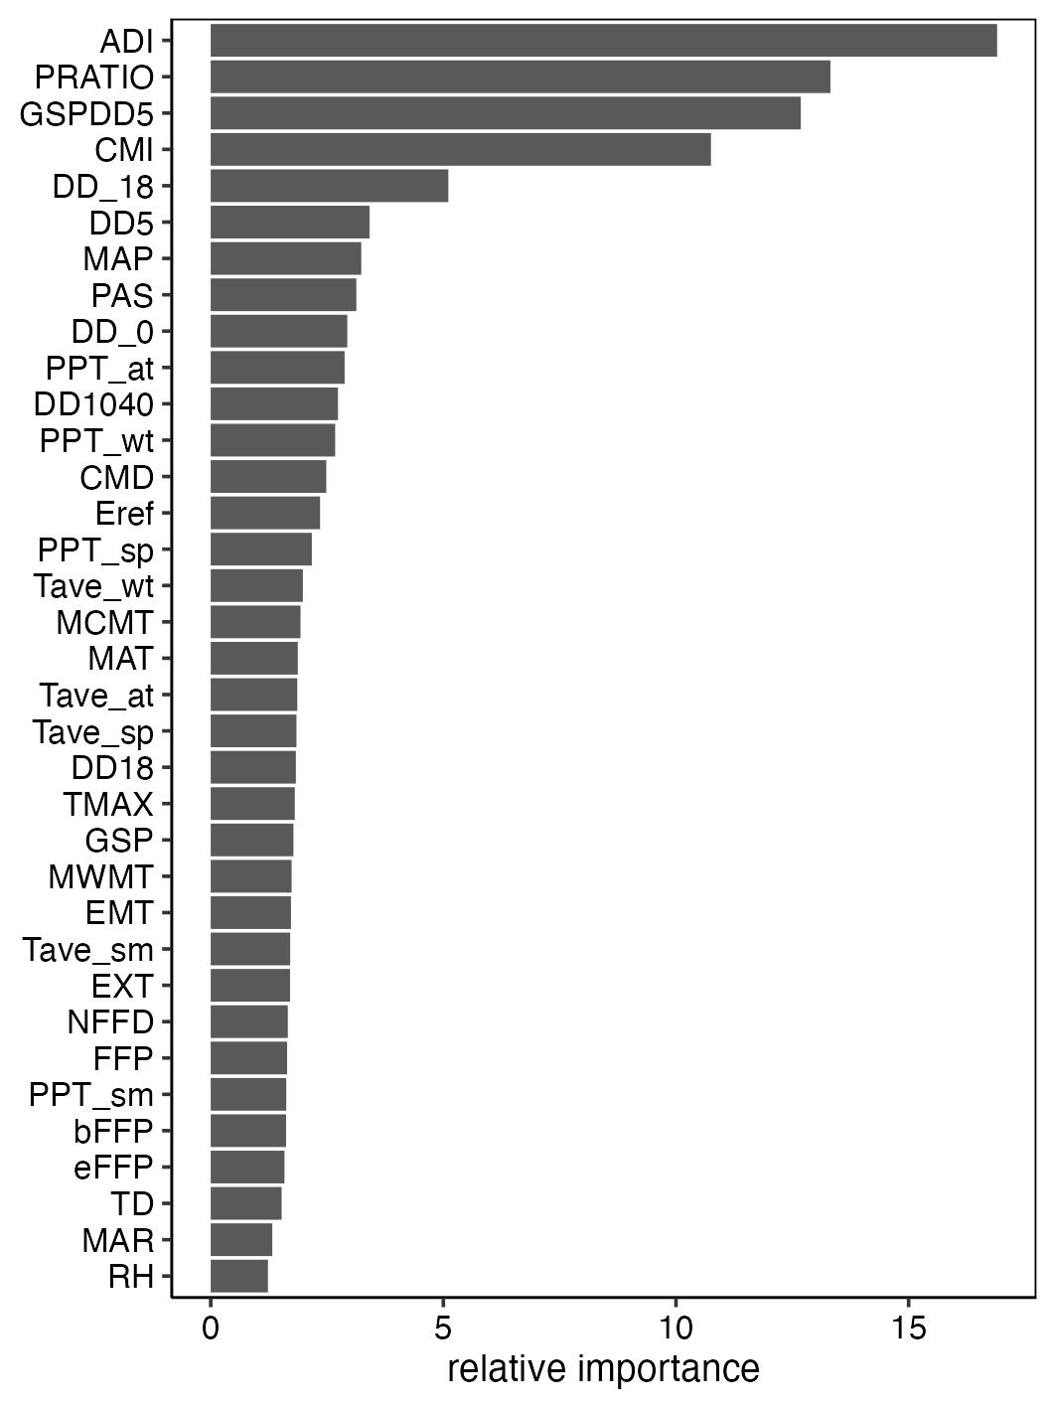

Figure 8: Contribution of climate predictor variables to univariate random forests models

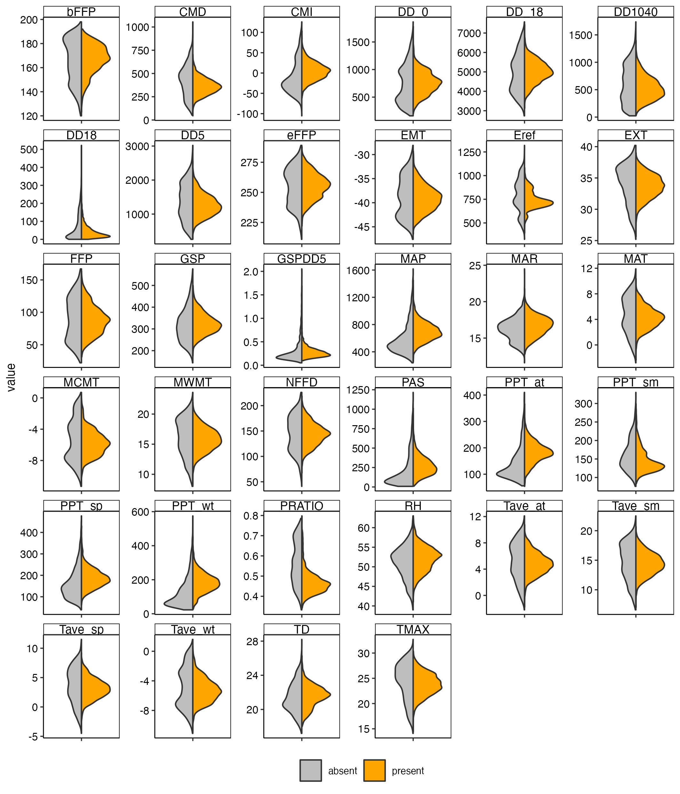

Figure 9: Paired violin plots illustrating the

# Appendix C: Supplemental figures

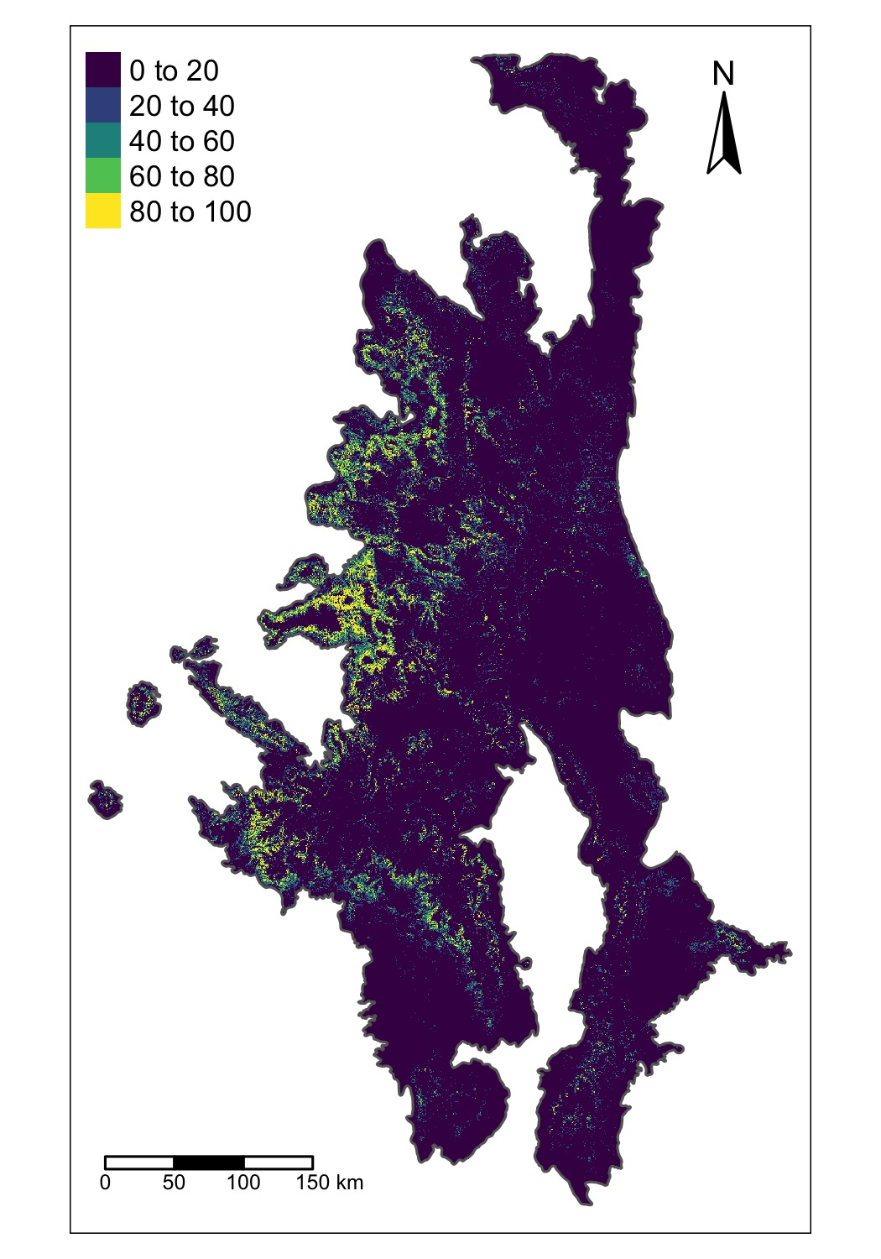

Figure 10: Percent cover

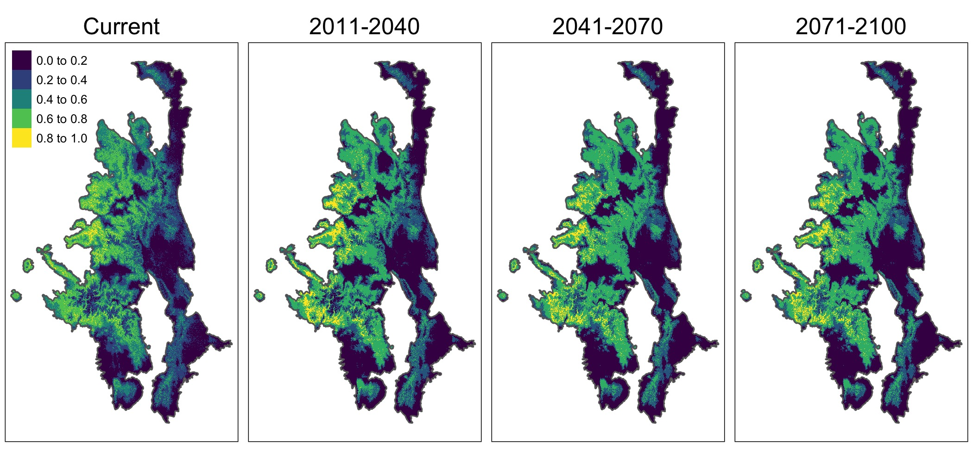

Figure 11: The ensemble projection of aspen habitat suitability under current conditions and projections for future periods based on the projected climate for the SSP5-8.5 scenario.

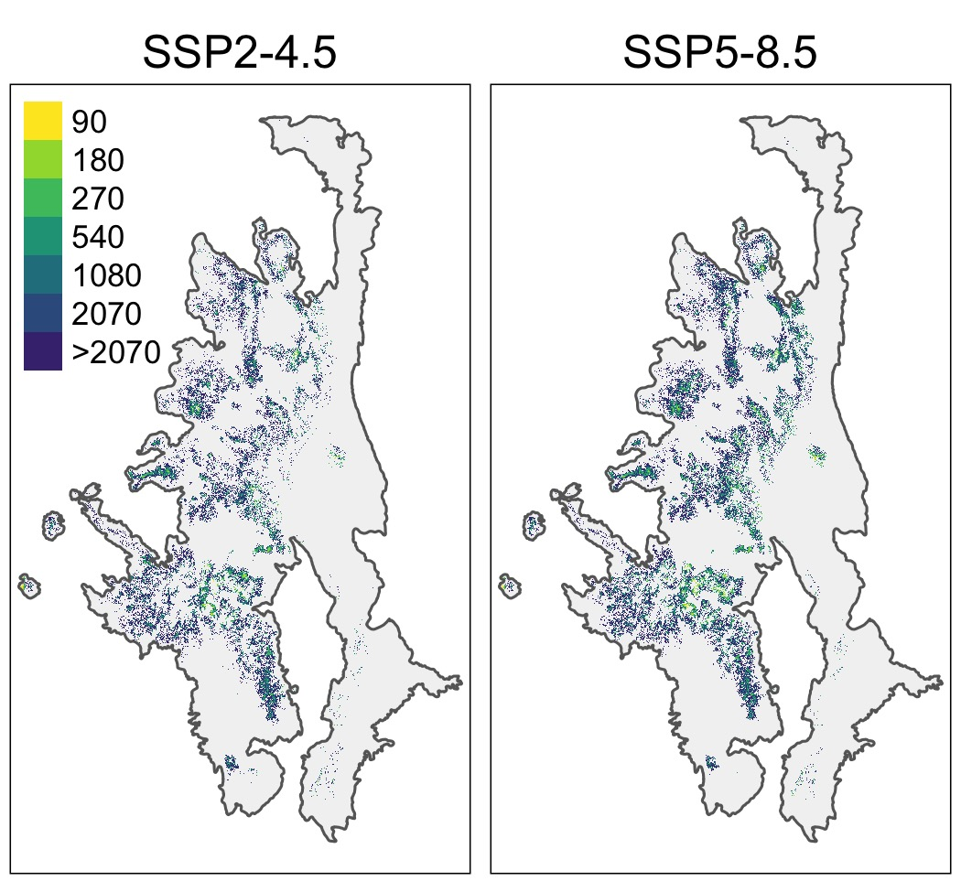

Figure 12: GainDistanceMaps

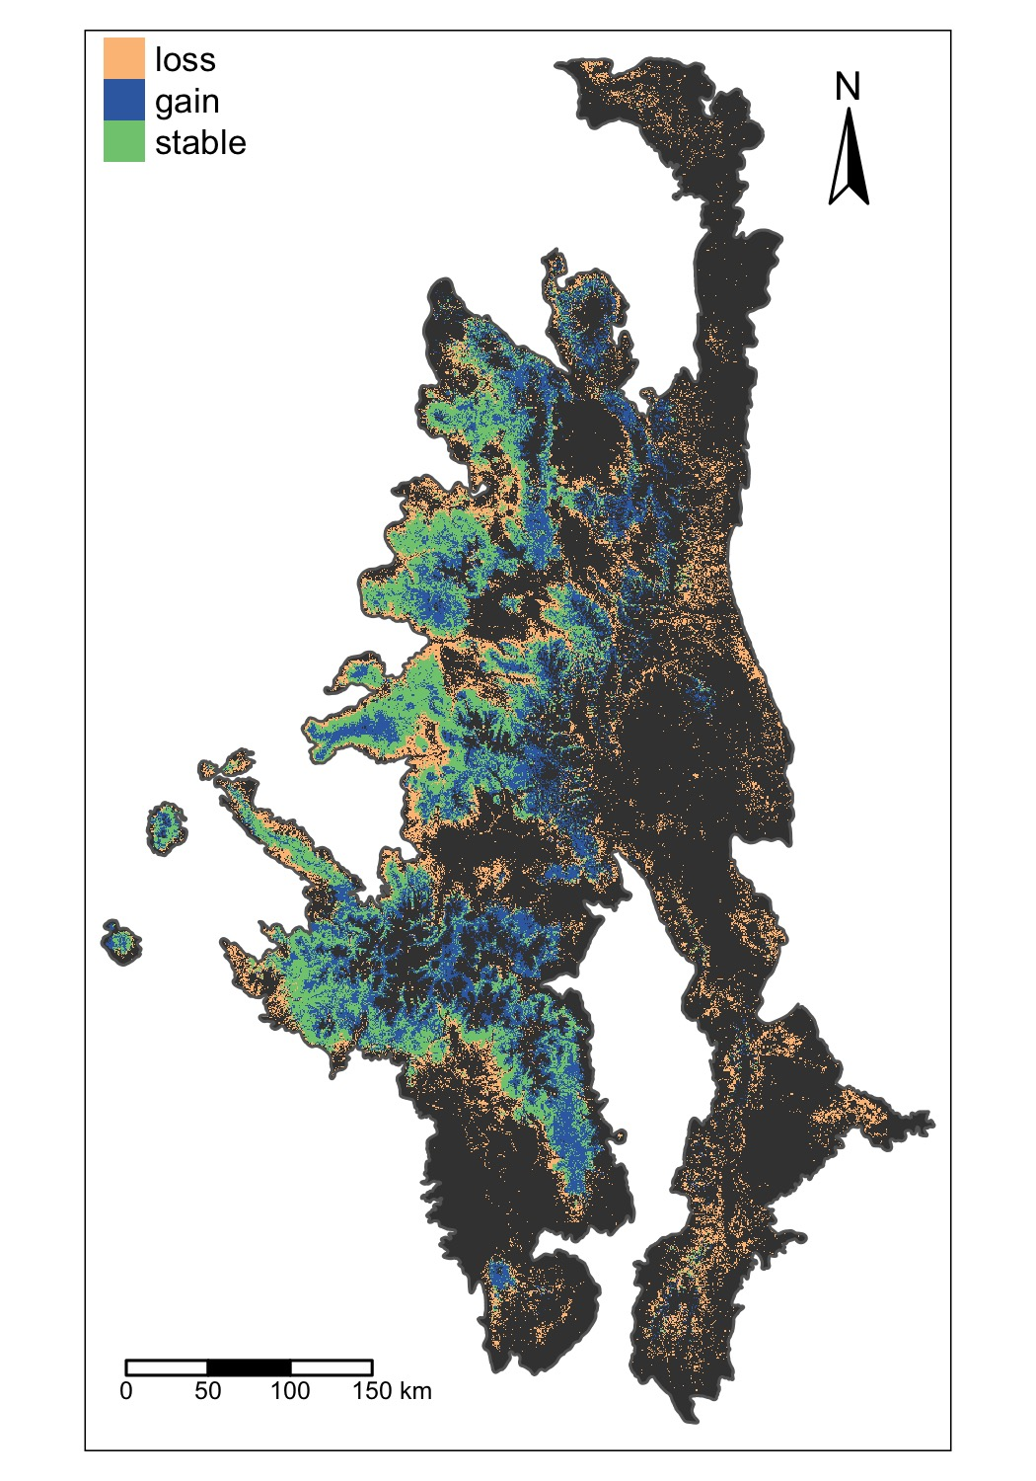

Figure 13: The distribution of pixels where the ensemble SDM forecasts aspen may be lost, gained, or stable by 2100 under the SSP2-4.5 scenario.